**Educational Networks Quick Parent & Student Guide**

**School Website link:** <https://bridgeprepduval.com/apps/account/profile.jsp>

Bulldog Parents and Families,

BridgePrep Academy staff is working diligently in preparing for the possibility that school officials could order school closures at any time, we have a plan that ensures that students will continue learning from home if the need arises. Our plan is for students to communicate with teachers online and through the educational portal, Educational Networks, in the event the school is ordered to be closed.

Currently students, teachers, and families are all doing well and are healthy. We are closely monitoring the COVID-19, commonly known as coronavirus, and paying attention to information from the Florida Department of Health and the Centers for Disease Control & Prevention (CDC).

BridgePrep has been taking the following measures:

• Extra cleaning at high frequency contact areas

• Adequately stocking hygiene supplies to include soap and hand sanitizer

This is an ever-changing situation. We will work closely together to provide you with updates on the information as it comes available to us. We will formulate a plan of action that will ensure safety, on-going education/teaching to all students in our schools or remotely. Please be sure to complete the survey sent from the school. This survey will inform us of the technology our students have access to use. Education is key! And education cannot stop in the case of extended time out of school. Students will still receive educational opportunities following protocol from Florida Department of Health and Florida Department of Education by providing a technology remote access to learning via our school website and the technology programs students have been using daily. Please check our school website daily for any new information and assignments.

As always, BridgePrep Academy is here to serve you and your families.

In the best interest of children,

BridgePrep Academy of Duval

**New Student Accounts**

1. A new student must visit your school website and create their account using the **Create Account** form.

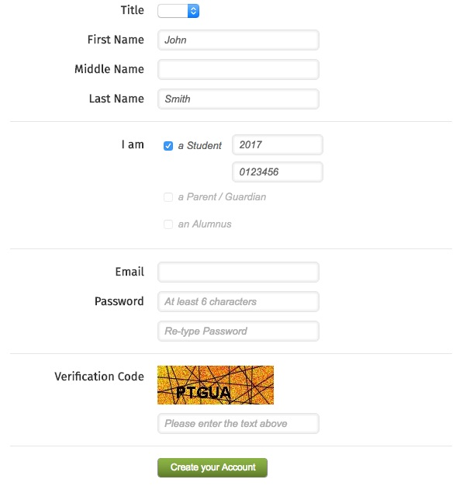

1. After completing the new account form, a student will receive an email to verify their email address and activate their account. They must click the **Activate Account** button in the email they receive.

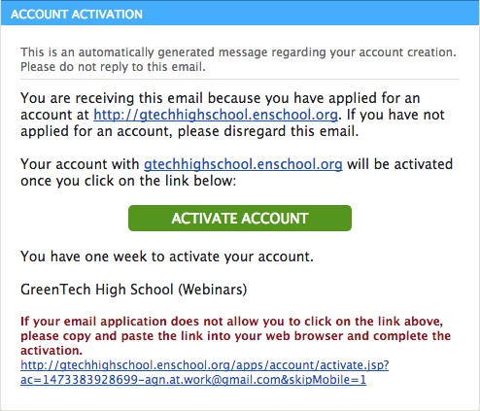

1. After activating their account, they will receive an email with a **verification code**

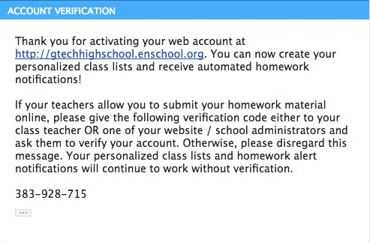

1. The student must then physically give their verification code to one of their teachers.
2. The teacher must then click on **My Students and Parents** from their admin area, and then click on the **Verify Student Accounts** button.

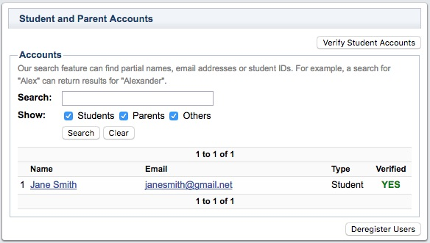

1. The teacher will then enter the verification code provided by the student.

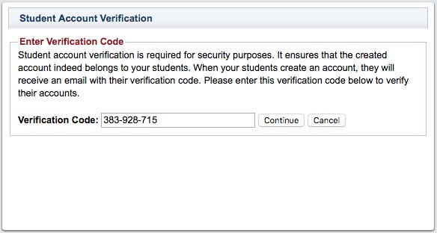

1. After reviewing the student's information, click on the **Approve** button to complete the student verification process.

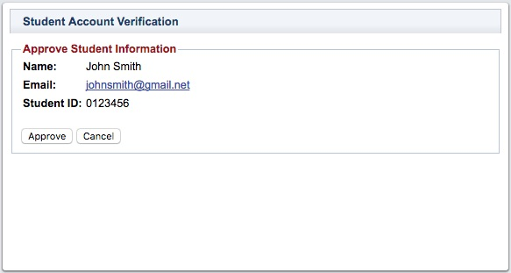

If your website doesn't have a Login / Create Account option, please contact Technical Support using the help desk and request for it to be added somewhere on your. [show me](javascript:;)